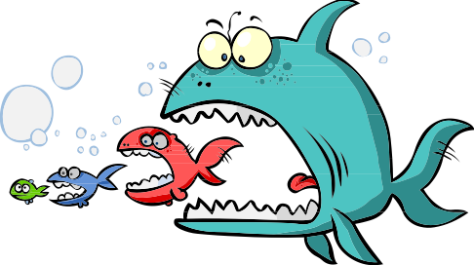
Natural Selection of “Strawfish” Activity
Data Table

Test 1: Preferential Predation - In this test, the predators discover that the yellow allele made a sour-tasting protein.

Which fish contain the yellow allele? _____________________________ Which fish will the predators prefer to eat? _____________________________

 | # of Surviving Fish
Generation # | Blue | Green | Yellow | Total
1 (control)
2
3
4
 | Surviving Alleles
Generation # | Blue | Yellow | Total
1 (control)
2
3
4
 | Frequency of Surviving Fish
Generation # | Blue | Green | Yellow
1 (control)
2
3
4
 | Surviving Allele Frequency
Generation # | Blue | Yellow
1 (control)
2
3
4
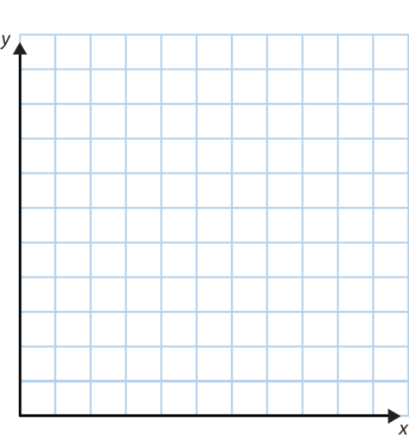
Analysis Questions:
- Did the frequency of each color change much from generation to generation in this test? Explain.
- Did the allele frequency change much over the 4 generations in this test? Explain
- What is causing this change (or lack of change) in allele frequency?
- What do you think will eventually happen to the frequency of each allele in this population?
- What type of selection pattern or trend does this simulation represent (directional, stabilizing, or disruptive)?

Natural Selection of “Strawfish” Activity
Data Table

Test 2: Preferential Predation - In this test, the predators discover that the blue allele made a sour-tasting protein.

Which fish contain the blue allele? _____________________________ Which fish will the predators prefer to eat? _____________________________

 | # of Surviving Fish
Generation # | Blue | Green | Yellow | Total
1 (control)
2
3
4
 | Surviving Alleles
Generation # | Blue | Yellow | Total
1 (control)
2
3
4
 | Frequency of Surviving Fish
Generation # | Blue | Green | Yellow
1 (control)
2
3
4
 | Surviving Allele Frequency
Generation # | Blue | Yellow
1 (control)
2
3
4
Analysis Questions:
- Did the frequency of each color change much from generation to generation in this test? Explain.
- Did the allele frequency change much over the 4 generations in this test? Explain
- What is causing this change (or lack of change) in allele frequency?
- What do you think will eventually happen to the frequency of each allele in this population?
- What type of selection pattern or trend does this simulation represent (directional, stabilizing, or disruptive)?

Natural Selection of “Strawfish” Activity
Data Table

Test 3: Preferential Predation - In this test, the predators discover that the green fish are particularly flavorful.

Which alleles will a green fish have? _____________________________ Which fish will the predators prefer to eat? _____________________________

 | # of Surviving Fish
Generation # | Blue | Green | Yellow | Total
1 (control)
2
3
4
 | Surviving Alleles
Generation # | Blue | Yellow | Total
1 (control)
2
3
4
 | Frequency of Surviving Fish
Generation # | Blue | Green | Yellow
1 (control)
2
3
4
 | Surviving Allele Frequency
Generation # | Blue | Yellow
1 (control)
2
3
4
Analysis Questions:
- Did the frequency of each color change much from generation to generation in this test? Explain.
- Did the allele frequency change much over the 4 generations in this test? Explain
- What is causing this change (or lack of change) in allele frequency?
- What do you think will eventually happen to the frequency of each allele in this population?
- What type of selection pattern or trend does this simulation represent (directional, stabilizing, or disruptive)?

Natural Selection of “Strawfish” Activity
Data Table

Test 4: Heterozygote Advantage - In this test, the predators discover that the green fish are camouflaged.

Which fish will the predators prefer to eat? _____________________________

 | # of Surviving Fish
Generation # | Blue | Green | Yellow | Total
1 (control)
2
3
4
 | Surviving Alleles
Generation # | Blue | Yellow | Total
1 (control)
2
3
4
 | Frequency of Surviving Fish
Generation # | Blue | Green | Yellow
1 (control)
2
3
4
 | Surviving Allele Frequency
Generation # | Blue | Yellow
1 (control)
2
3
4
Analysis Questions:
- Did the frequency of each color change much from generation to generation in this test? Explain.
- Did the allele frequency change much over the 4 generations in this test? Explain
- What is causing this change (or lack of change) in allele frequency?
- What do you think will eventually happen to the frequency of each allele in this population?
- What type of selection pattern or trend does this simulation represent (directional, stabilizing, or disruptive)?

